Title: The length of the title is up to 12 words, without abbreviations. It should be placed with size 18, letter font Constantia in bold, single line spacing, justified text paragraphs and uppercase only in main words, without identifying the authors.

ABSTRACT

These instructions provide you with the guidelines for preparing papers for Revista de Negócios. Use this document as a template if you are using Microsoft Word. Otherwise, use this document as an instruction set. An abstract should include no more than 250 words, written in Constantia letter, size 10, single line spacing, justified text paragraph and should follow a structure formed by six steps: The purpose, methodology, research findings, research limitations and implications and originality. The purpose is the reason(s) for writing the paper or the aims of the research. The methodology includes the objectives achieved; main method(s) used for the research and the theoretical or subject scope of the paper. The findings include what was found in the course of the work, referring to analysis, discussion and results. The research limitations/implications include suggestions for future research and any identified limitations in the research process. And the last one is the research originality, which include the explanation about what is new in the paper.

KEYWORDS

Authors should provide appropriate and short keywords. The maximum number of keywords 5, separated with commas, letter Constantia, size 10, single line spacing and justified text paragraph.

1 Introduction

The article must follow a structure formed by: introduction, theoretical framework, methodology, analysis, conclusion, implications, future research and references. Paper must not exceed 30 pages. The font used for the text is Times New Roman, size 12, including titles, subtitles and references. It must be used single space, being the first line: indent 1 cm. The paragraphs in justified text and the pagination including the number of pages in the upper right, dismissing the first page.
Use bold letter to give emphasis to the terms, phrases and/or symbols and italics letter should only be used for words in a foreign language.
The double quotation marks used for direct quotes as well as statements taken from interviews and single quotation marks used within double quotation marks to separate material that was within quotation marks in the original source.
For an article with one author, it can be written in the first person singular or the third person impersonal. In those articles with more than one author, it can be written in the first person plural or third person impersonal. The abbreviations and acronyms should use parentheses to introduce. Brackets are used to separate material within parentheses or text inserted in a citation by another person who is not the original author.
Sections and subsections should have : multilevel numbers indicating section and subsections, before their respective titles, following the format:

2 Theoretical Framework
2.1 Article subsection
2.1.1 Article subsection
2.1.1.1 Article subsection

In case of acknowledgments, the authors may include acknowledgments as long as they do not reveal their identities. Otherwise, authors may include the acknowledgments after approval. Minimize the use of footnotes, since essential material should be integrated into the text.
Try to use the first person only to describe what you or you and your coauthors, actually did.
Regarding the introduction section, it states the motivation for the work presented in the research and prepare readers for the upcoming structure. It starts broadly and progressively narrowing it down to the issue addressed in the paper (main purpose).
It might be interesting to describe the importance, defending the model or theoretical point of view and state the specific hypothesis(es) or even the objective(s), describing the reasoning that led the author to select them.
The introduction should be written in past tense, except when referring to established facts, since the paper will be submitted after all of the work is completed. The ideas may be organized in different paragraphs. The introduction does not have a strict word limit, but it should be as concise as possible.

2 Theoretical Framework

The theoretical framework composed by theories, which leads the reader to grasp the author’s perspective.
It is important to examine the research problem and research question in order to answer the investigation concerns and variable keys of the research. After that, the author will be able to read and review related current literature. List the constructs and variables that might be relevant to the study and consider how these variables connected to the theory. The hypotheses phrase is in the present t tense and refer it with a distinct number. It should be in italic font.
In the end, it might be important to discuss the assumptions or propositions of each theory and point out its relevance to the research.

3 Methodology

The methods section provides the information by which a study’s validity is evaluated. It requires a clear and precise description of how an experiment had been developed, and describe why specific experimental procedures were chosen. The methods section describes what was done to answer the research question, justifying the experimental design, and explaining how the results were analyzed. Scientific writing is direct and orderly. Therefore, the methods section still describes how the materials were used, depicts the research protocol, explains how measurements were made, what calculations were performed, and finally, states which statistical tests were done to analyze the data.

4 Analysis

This part analyzes the collected data and interpret the results. The analysis will include data summaries and statistical tests to verify conclusions. It is connected with the discovered information and the theory proposed in the theoretical framework.

4.1 Tables and Figures

Tables and figures should be used, according to the APA style (2010), allowing the author to present a larger quantity of information to the reader, in a more efficient and easily understood manner than in written text. The tables and figures must not replicate the information previously included in the text. Therefore, any information that is not in textual form should be in the form of a table or figure. In specific cases, it is allowed terms such as graphic, map, fluxogram, design, photograph, etc. They should follow the same conditions of tables and figures.
According to the APA style (2010), Tables and Figures normally “show numerical values or textual information (e.g., lists of stimulus words) arranged in an orderly display of columns and rows. A figure may be a chart, a graph, a photograph, a drawing, or any other illustration or nontextual depiction” (APA, 2010, p. 125). Tables are usually characterized by a line-column structure; thus, other types of illustrations, which differ from this characteristic, should be labeled as figures. Tables and Figures should be inserted in the body of the text, soon after their reference or citation. Following bellow an example of Table and Figure:

Table 1. Tables, tables, tables
Tables | Figures | Figures | Figures
Tables | Figures | Figures | Figures
Tables | Figures | Figures | Figures
Tables | Figures | Figures | Figures
Source: Tables (2015)

Figure 1. Figure, figure, figure
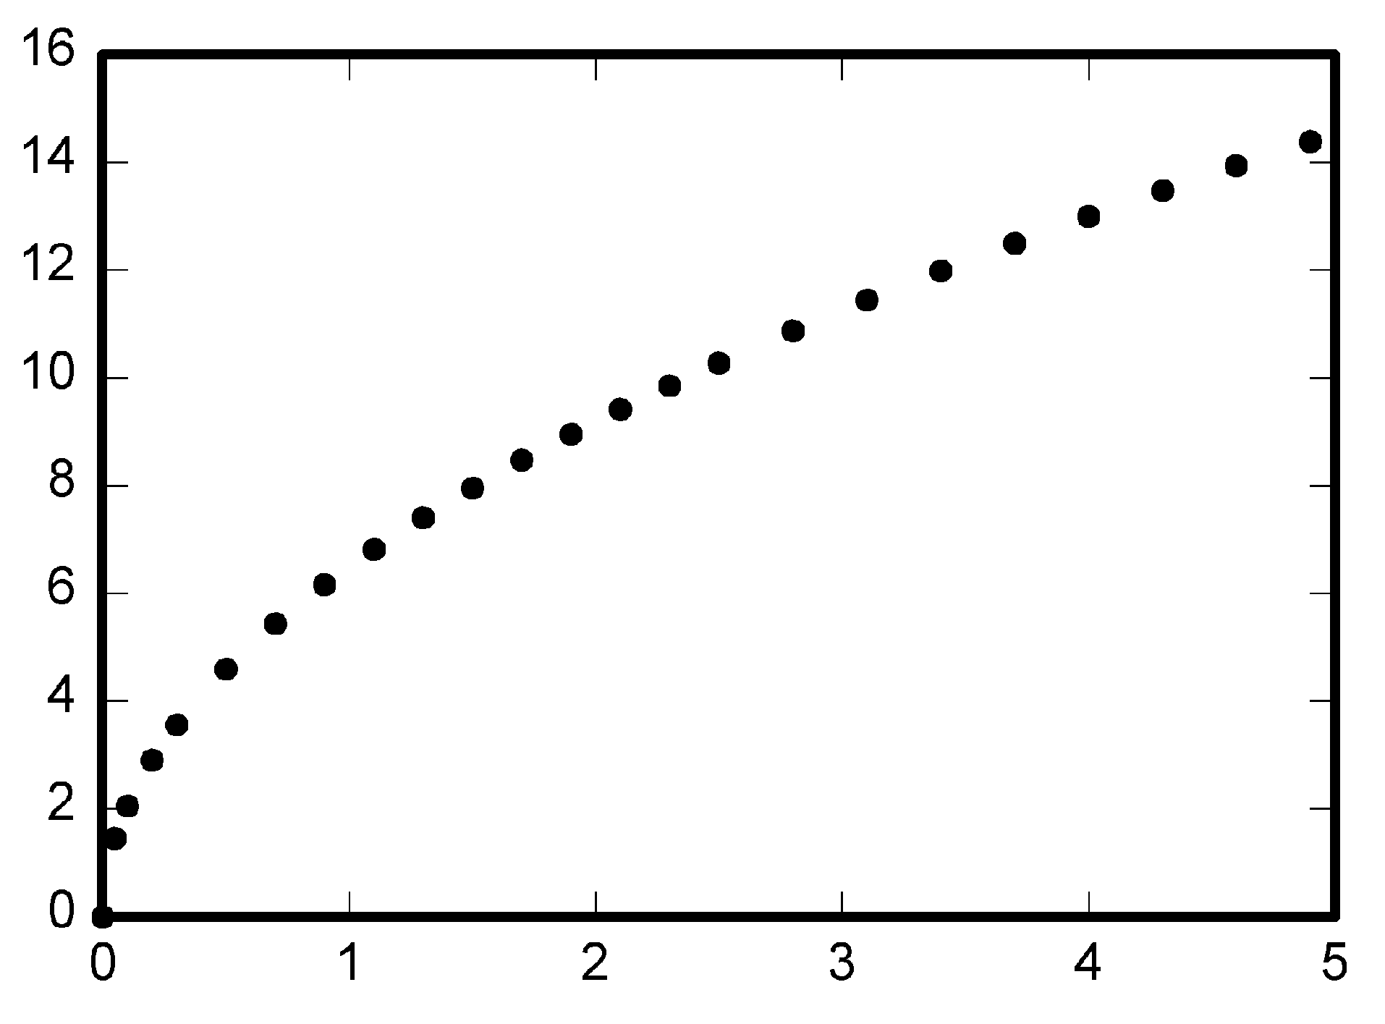
Source: Figures (2015)

5 Conclusion

The conclusion is one of the last parts to be written in the research paper. It must answer the research questions, concluding with the main findings. It reviews the main points of the paper, not replicating the abstract.

6 Implications and Further Research

This part should describe the main professional and academic implications of the research findings, appointing to the consequences and suggestions. The future research signalizes what should be researched next, suggesting new theoretical approaches in the academic field.

7 References

The reference list should include complete data for all authors cited, presented in alphabetical order at the end of the text, in accordance with the American Psychological Association style (APA, 2010). Following some examples bellow:

Books: Last name, First initial (capitalized followed by a period). (Publication year within parentheses). Title: subtitle (if any) (additional information, if any). Publication location: Editor.

Example: Jarzabkowski, P. (2005). Strategy as practice. London: Sage.

Journal: In order to cite a complete edition of a periodical/journal in its entirety, indicate the authors of the edition, the title, volume, and (edition number within parentheses).

Example: Quintella, R. H., & Carneiro, J. (Eds.) (2011). Brazilian Administration
Review, 8(3).

Eletronic version: Use ‘Retrieved from’ and add the link (web address) to access the article.

Example: Castañeda, D. I., & Ríos, M. F. (2007). From individual learning to organizational learning. The Electronic Journal of Knowledge Management, 5(4), 363-372. Retrieved from: http://www.ejkm.com/issue/download.html?idArticle=120

  - Citations

Citations in the body text should include the author’s last name, the date of publication, and page number (if necessary), as conforms to the APA style (2010).

1 author: Author (year)
2 authors: Author and Author (year)
More than 3 authors: Author et al.,(year)

7.2 Foot-Note Pages

The Foot-Note Pages must be filled out as Revista de Negócios volume, number, page, month and year.

  - In Case of Article Approval

In the case of conditional approval, the authors should submit the article pointing to the revisions in red color. Eventually, if the submitted article is disqualified in this second review, the copyrights transfer statement will be discarded. The article will not be published without containing the copyrights transfer statement as mentioned above.

  - Publication Principles

The submitted article must not be published before under any circumstances– neither in total (e.g. book chapters) nor in parts (e.g. excerpts). It should not been accepted previously for publication and it has not been under momentary consideration by any other publisher. It should not be submitted elsewhere until a decision is made with regard to their publication in Revista de Negócios. The only exceptions for the conditions above are papers in conference proceedings being treated as work-in-progress. All submitted papers can be written in English or Portuguese, however with the article acceptance, the author(s) must sign the English translation statement, confirming that the article will be written in English.
In order to contribute to the blind review process, it must not contain any identification of the authors in the file and the in the properties option in Word, thus ensuring the journal's confidentiality criteria. It is restricted to authors and co-authors to submit two papers every 12 months continuously to the Revista de Negócios. It is also allowed a maximum of 5 authors per manuscript.

  - Plagiarism Policy

Uppermost respect to intellectual property rights is a fundamental principle of RN Codes of Ethics. The act of plagiarism, in which one misuses ideas, words, computer codes or other creative expression as one of its own, is a clear violation of several ethical principle. Plagiarism in any kind of form, at any level, will be acceptable and will be considered a serious breach of professional conduct, with potentially severe ethical and legal consequences. Self-plagiarism is also a related issue regarding the reuse of significant portions of one's own copyrighted work without citing the original source. Such actions will not be considered for publication in our journal. All authors are responsible individually and collectively for the articles submitted to RN.

